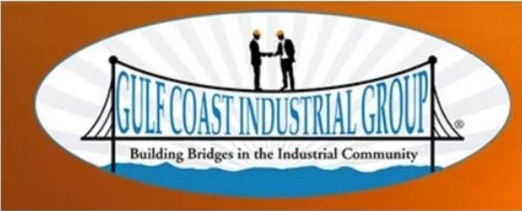
GREATER HOUSTON INDUSTRIAL GROUP
Sponsorship Opportunities

PLATINUM SPONSORSHIP $5000/YR  - Logo will be put on CHIRP Report for 1 year  - Logo will be put on GHIG Banner for events.  - Company information will be provided to guest speakers.  - Logo will be put on the big screen at every meeting.  - Company name will be mentioned from the podium at every meeting.  - Company name will be mentioned on all Greater Houston Industrial Group social media platforms.  - Introductions to guest speakers at the monthly meetings.  - Annual dues are waived for sponsored year.  CHIRP REPORT Sponsor $300/month  Booth at GHIG Meeting $200/month | GOLD SPONSORSHIP $3500/YR  - Logo will be put on the big screen at every meeting.  - Company name will be mentioned from the podium at every meeting.  - Company name will be mentioned on all Greater Houston Industrial Group social media platforms.  - Introductions to guest speakers at the monthly meetings.  - Annual dues are waived for sponsored year.  SILVER SPONSORSHIP $1500/YR  - Logo will be put on the big screen at every meeting.  - Company name will be mentioned from the podium at every meeting.  - Company name will be mentioned on all Greater Houston Industrial Group social media platforms.  - Annual dues are waived for sponsored year.
STUDENT SPONSORSHIP $6,000 ($3000/YR)

- Sponsor a student at San Jacinto College for their complete two (2) years.
- Logo will be put on the big screen at every meeting.
- Company name will be mentioned from the podium at every meeting.
- Company name will be mentioned on all Greater Houston Industrial Group social media platforms.
- The Student and Company will have a chance to speak at one meeting/year.
- Annual dues are waived for sponsored years.

